# Paper Title Maximum 15 Words (Times New Roman, Bold, 14)

# First Author1, Second Author2, Third Author3

1 Academic title, Department, University or Organization, City, Country, Email address.

2 Academic title, Department, University or Organization, City, Country, Email address.

3 Academic title, Department, University or Organization, City, Country, Email address.

## Abstract

This guideline explains how to prepare a paper for submission to the 1st International Conference on Standards and Standardization in Marine Industries. The abstract of the paper should include a definition of the problem, assumptions, solution method, a summary of the main results, and validation of results. The conference proceedings will be generated directly from the Word or PDF file. The abstract should be between 150 and 250 words, typed in Times New Roman, regular, size 10 pt. All formatting will be automatically applied through the provided template files.

## Keywords

Keywords should be between a minimum of 3 and a maximum of 5 words, separated by commas.

## Introduction

This guideline has been prepared as a template for writing papers in Microsoft Word. Please follow it carefully to ensure consistency and uniformity in the formatting of all papers. The English text of the paper should be written in regular Times New Roman size 10 pt. Authors are kindly reminded that the paper must not exceed 8 pages.

After opening this guideline, you can easily prepare your paper according to the conference format by rewriting each section. Authors are strongly encouraged to carefully follow the instructions below when preparing their paper. We are confident that the esteemed authors will consider this attention to detail essential for enhancing the quality of the conference and will regard adherence to these guidelines as necessary.

## Paper main body

The paper should include the following sections: Conference title (at the top of the first page), Paper title, author name(s) along with their academic titles, institutional affiliation, and email address(es), Abstract, Keywords, Introduction, Main body of the paper, Conclusion, Acknowledgments (if necessary), List of symbols, References.

All papers must include an abstract. The abstract should present the research method, key findings, and their evaluation. There is no need to mention the background of the topic in this section. The introduction should include the problem definition, background, and scientific context of the topic, with references to sources. Citations should be indicated by reference numbers, e.g. [1]. In the final paragraph of the introduction, the scientific and technical contributions of the research, as well as its novelty compared to previous studies, must be clearly and explicitly stated.

Depending on the nature of the paper, the main body should be appropriately structured and divided by the author(s). The conclusion section should present and discuss the key findings of the paper. In addition, detailed results should be included as part of the main text. All sources cited in the paper must be listed in the references section in the order they appear in the text.

The font size for the paper title should be 14 pt in bold Times New Roman, centered. The font size for the author(s) name(s), academic title(s), and institution name(s) should be 10 pt in bold Times New Roman. The font for English articles should be B Nazanin, while for English articles it should be Times. The font size for the main body text in English should be 10 pt.

The papers should be typed on A4 paper in two columns, with a 20 mm margin on the top, bottom, left, and right. The space between the columns should be 8 mm. Authors may use this sample to format their paper. Additionally, the line spacing should be single. The first line of the introductory paragraph in each section does not need to be indented, but for other paragraphs, a 5 mm indentation should be used.

## Equations

Equations must be typed (not as images) in the paper. Additionally, equations should be numbered sequentially from the beginning to the end. The equation numbers should be placed at the far right of each column, aligned with the line containing the equation, and enclosed in parentheses.

 (1)

When referring to an equation, its number must be mentioned. For example, use the phrase "Equation (1)" or "Relation (1)".

## Figures and Tables

Figures should be placed within the specified frame, and the numbers, letters, and symbols within them must be clear and visible. All figures and tables should appear at the first appropriate location after they are referenced. If a figure has multiple parts, use indicators such as (a), (b), (c), etc., below the figure parts, along with the figure title and explanations in the text. All tables and figures must be numbered sequentially. Figures should have captions below them, and tables should have titles above them. There should be a single line space between the caption of a figure or the end of a table and the continuation of the text. Table 1 and Figure 1 are examples for a table and figure.

Table 1: Example of a table in paper.

|  |  |  |  |  |
| --- | --- | --- | --- | --- |
|  | Area (m2) |  |  |  |
| 1 |  |  |  |  |
| 2 |  |  |  |  |
| 3 |  |  |  |  |

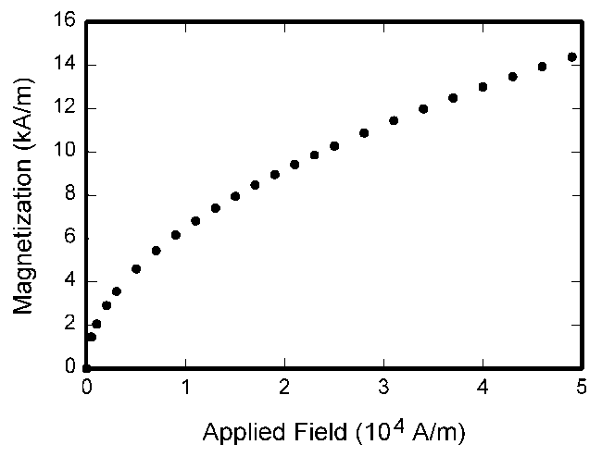

Figure 1: Example of a figure in paper.

## Acknowledgement

If necessary, authors may include acknowledgments to express their gratitude to the supporters of the research in this section.

## References

References cited in the text must be indicated by numbers in square brackets, such as [1]. Obviously, the full citation details of each source should be provided in the References section using the same numbering. The order of references in the References section should follow the order in which they are cited in the text. Only the sources cited in the text should appear in the References section, no additional references should be included. The format for writing references should follow the order described below:

1. Author, A., Author, B., and Author, C., 1994. “Article Title”. *Journal Name*, 1(5), May, pp. 1–3.
2. Author, A., 1986. *Book Name*. Publisher Name, Address.
3. Booklet, A., 1994. Booklet title. On the WWW, at http://www.abc.edu,May. PDF file.
4. Inbook, A., ed., 1991. *Book title*, 1st ed., Vol. 2 of Series Title. Publisher Name, Publisher address, Chap. 1, pp. 1– 3. See also URL <http://www.abc.edu>.
5. Incollection, A., 1991. “Article title”. In *Collection Title*, A. Editor, ed., 3rd ed., Vol. 2 of Series title. Publisher Name, Publisher address, May, Chapter 1, pp. 1–3. See also URL http://www.abc.edu.
6. Inproceedings, A., 1991. “Article title”. In Proceedings Title, A. Editor and B. Editor, eds., Vol. 1 of *Series name*, Organization Name, Publisher Name, pp. 1–3. Paper number 1234.
7. ASME, 2003. *ASME Manual* MS-4, *An ASME Paper*, latest ed. The American Society of Mechanical Engineers, New York. See also URL http://www.asme.org/pubs/MS4.html.
8. Mastersthesis, A., 2003. “Thesis Title”. MS Thesis, University of Higher Education, Cambridge, MA, May. See also URL http://www.abc.edu.
9. Misc, A., 2003. Miscellaneous Title. On the WWW, May. URL http://www.abc.edu.
10. PhD thesis, A., 2003. “Thesis Title”. PhD Thesis, University of Higher Education, Cambridge, MA, May. See also URL http://www.abc.edu.
11. Proceedings, A., ed., 1991. Volume Title, Vol. 1 of *Proceedings Series*, Organization Name, Publisher Name. See also URL http://www.abc.edu.
12. Techreport, A., 2003. Techreport title. Progress report 1, University of Higher Education, Cambridge, MA, May. See also URL http://www.abc.edu.